- In SMART Pages, click on “Search/Download by Funding,” and enter the program code. You can search by program name if you do not know the code). Make sure the aid year is set to the appropriate year.

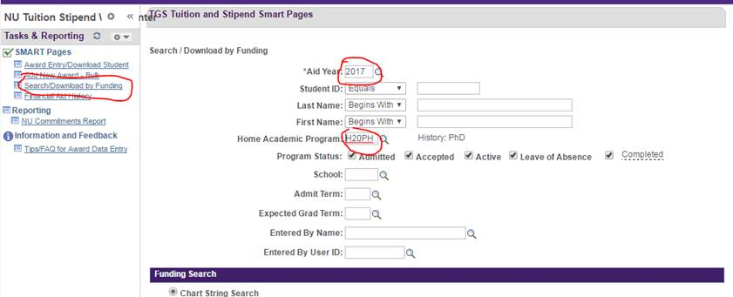

2. Click “Search” at the bottom, and scroll down to see the results.

3. Export the list to Excel by clicking on the grid. You can view the results without exporting, but it is much easier to read the data in Excel.

4. Scroll over to the right to where you see the columns Disb 1, Disb 2, etc. Those columns correspond to the months (Disb 1=Sept, Disb 2=Oct etc.) for stipend and quarters (Disb 1=fall, Disb 2=winter etc.) for tuition. (In the example below, the panes are frozen after admit term). Disb 10, 11, and 12 are the summer quarter stipend. Disb 4 is the summer tuition. In the example below, Diana Prince has summer funding entered (circled in red), but John Snow does not (circled in blue).

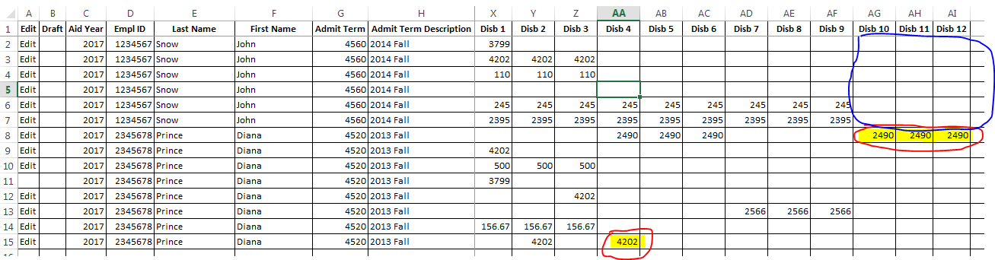

5. Once you have determined which students do not have funding (or only have partial funding), check if they are supposed to be funded, and if they are, take action as soon as possible to make sure they are funded/paid properly.

