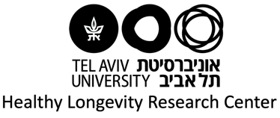
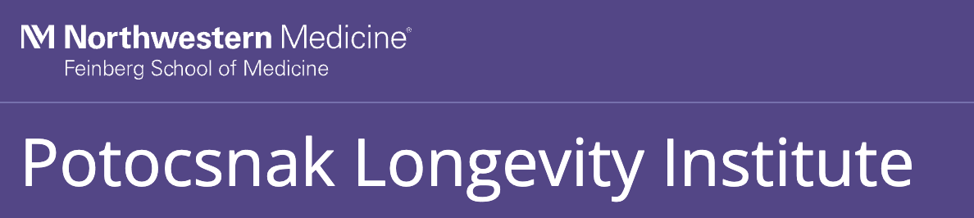



Application Form for Northwestern-Tel Aviv-Toronto
Joint Call for Proposals: Longevity and Healthy Aging

Please note: A single joint application should be submitted. Please complete and be sure to save this application form. Then, one of the co-PIs should upload the application materials through this Link.

PROJECT TEAM

PIs | Northwestern | Tel Aviv | Toronto
Applicant First Name
Applicant Last Name
Primary Appointment Title
Department/College/Faculty
Email Address
Team member's First Name
Team member's Last Name
Team member's Primary Appointment Title
Team member's Department/College/Faculty
Team member's Email
+Add rows for additional team members, as needed

Abbreviated Curriculum Vitae
Submit copies of all PIs’ CVs with a selected list of publications (each not more than 2 pages)

PROJECT DESCRIPTION

PROPOSAL TITLE
[Max 250 characters]

PROPOSAL ABSTRACT
[Max 200 words]
Please note that this abstract may be published online and used in communications and publicity materials if a grant is awarded.

PROJECT TIMELINE AND PLANNED ACTIVITIES
[Max 200 words]
For example, seminars, short courses, visits to other institutions that carry out research/teaching activities in cognate areas, etc., including rationale and timeline.

COMPLEMENTARITY
[Max 250 words]
A short description of how the proposed activities combine mutual areas of interest and strength, and the added value of this combined expertise.
RESEARCH PROPOSAL
[Max 1000 words]
SPECIFIC AIMS OF THE PROJECT
[Max 200 words]
INNOVATION/NOVELTY OF THE PROJECT
[Max 200 words]
RESEARCH PLAN
[Max 600 words]

RATIONALE AND POTENTIAL IMPACT
[Max 1000 words]
SCHOLARLY IMPACT
describe expected academic gains resulting from the cooperation, and identification of corresponding performance indicators (e.g. a publication, blog, meeting report etc.)
[Max 250 words]
BROAD IMPACT
alignment with the participating institutions’ strategic priorities and anticipated benefits of the project to local or international communities
[Max 250 words]
EARLY CAREER AND GRADUATE RESEARCHER INVOLVEMENT
opportunities for their engagement and anticipated benefits to the project and to the early career and graduate researchers themselves, as applicable
[Max 250 words]
CAPACITY FOR FUTURE COLLABORATION
a description of future potential collaborations that will be possible as a result of receiving seed funding
[Max 250 words]

PROPOSED BUDGET (up to a maximum of 12 months)
Please use the template below.

Provide a breakdown of costs to be charged to each university represented by a co-PI in this application. Use one line for each item (e.g. flights, hotels etc.).
 | Item(s) | Northwestern Max: 10,000 (USD) | Tel Aviv  Max: 10,000 (USD) | Toronto  Max: 14,000 (CAD)
1
2
3
4
5
6
7
8

Submission
Again, a single joint application should be submitted. Please complete and save this application form. Then, one of the Co-PIs should upload the application materials through this Link.

Further enquiries may be directed to the contact listed for your institution:
Northwestern University | Tel Aviv University | University of Toronto
Kim Rapp | Uri Ashery | Luke Li
kim.rapp@northwestern.edu | uriashery@gmail.com | luketx.li@utoronto.ca

