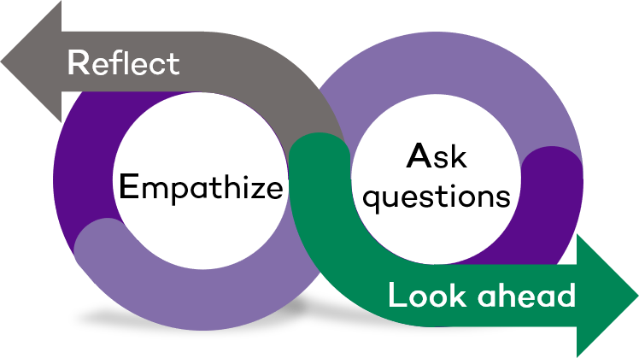
REAL (Reflect, Empathize, Ask Questions, Look Ahead)
Career Conversation 2 Discuss Progress: Guide for Managers
This REAL Career Conversation Guide is intended to prepare you for a conversation with your staff member where you can discuss progress toward their professional development goal and any additional resources they may need. This conversation is part of the Performance Excellence cycle and should occur around February each year.
Input your thoughts and responses to the questions from the guide into the planner included at the end.
Section 1: Reflect and Prepare
Take time to review your notes from Career Conversation 1. Are there any questions that stand out to you that you would like to ask your staff member?
To access training to prepare for this conversation, visit your myHR Learn account. From your account, go to the “Learning Playlists/LinkedIn Learning tab and find the training under the “Performance Excellence for Managers” tab.
You can also re-visit the two resources offered in the Career Conversation 1 Guide from the Center for Creative Leadership:
How to Have a Coaching Conversation
Use Active Listening Skills to Coach Others
Visit the Career Conversations 2 Discuss Progress: Guide for Staff to understand what types of questions staff members are considering when evaluating their progress and experience in working toward their professional development goal.
Sections 2-4: Empathize, Ask Questions, Look Ahead
Empathize
Working toward a professional development goal can be challenging. Celebrate the staff member’s successes in the past three months, acknowledge their challenges, and listen as they share their experience of working toward their goal.
Ask Questions
Consider asking two to three questions from the list below to better understand the staff member’s experience and progress toward their professional development goal:
- What have you discovered while working toward your goal -- about yourself, your goal, and your motivations?
- How do you feel about your progress?
- Where do you go from here? What are your next steps?
- How might I continue to support you in your professional development goal?
Look Ahead
Review these questions from the last session and help your staff member identify any changes, updates, or insights:
- At the end of this year, what will success look like for your professional development goal?
- What do you hope is true about your career in two years?

REAL Career Conversation 2 Discuss Progress: Planner for Managers
(For use with the Career Conversation 2 Discuss Progress: Guide)
Name of Staff Member:
Date:
Reflect: What skills or learnings from the training courses (offered in the Guide) do you want to remember in your conversation with your staff member? Are there any questions from your last Career Conversation that you would like to ask?

Empathize: Celebrate the staff member’s successes in the past three months, acknowledge their challenges, and listen as they share their experience of working toward their goal.

Ask Questions: Select two to three questions from the Guide that you want to ask in your conversation with your staff member.

Look Ahead: Consider the questions offered in the Guide to identify what is next.

Additional Questions: Make note of any additional items you would like to discuss with your staff member during Career Conversation 2.

