myHR Upgrade: Summary of Enhancements

On March 16, 2019, the Office of Human Resources, in partnership with Northwestern Information Technology, upgraded myHR offering new enhancements to improve the user experience. The enhancements included:

- New myHR Administration Dashboard
The new dashboard creates a more intuitive experience for administration users to navigate to key pages in myHR. To access the new myHR Administration dashboard from the home screen click Self Service and select Workforce Administration and then myHR Administration.

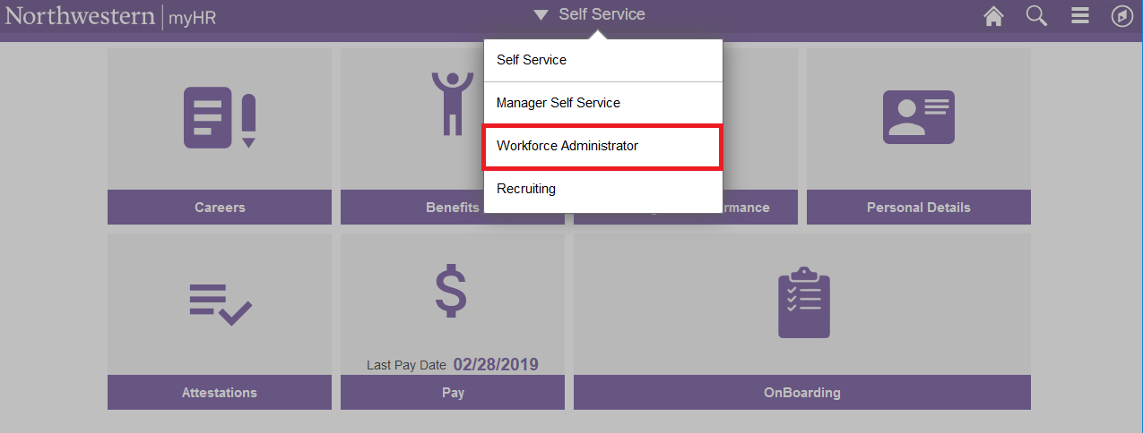

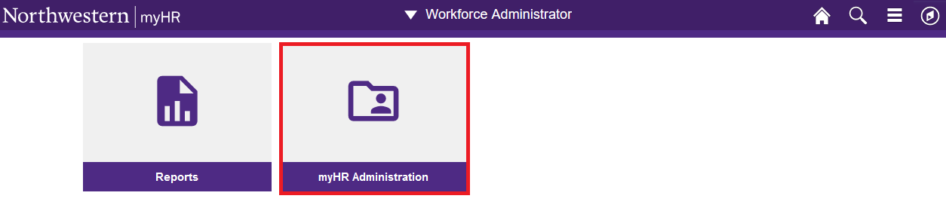

- New Recruiting Activities Dashboard
Recruiting Home has been replaced with a new Recruiting Activities dashboard. The new dashboard offers a more intuitive and user-friendly experience to reach key recruiting tasks such as My Job Openings or Create Job Opening. To access the new Recruiting Activities dashboard from the home screen click Self Service and select Manager Self Service and then Recruiting Activities.

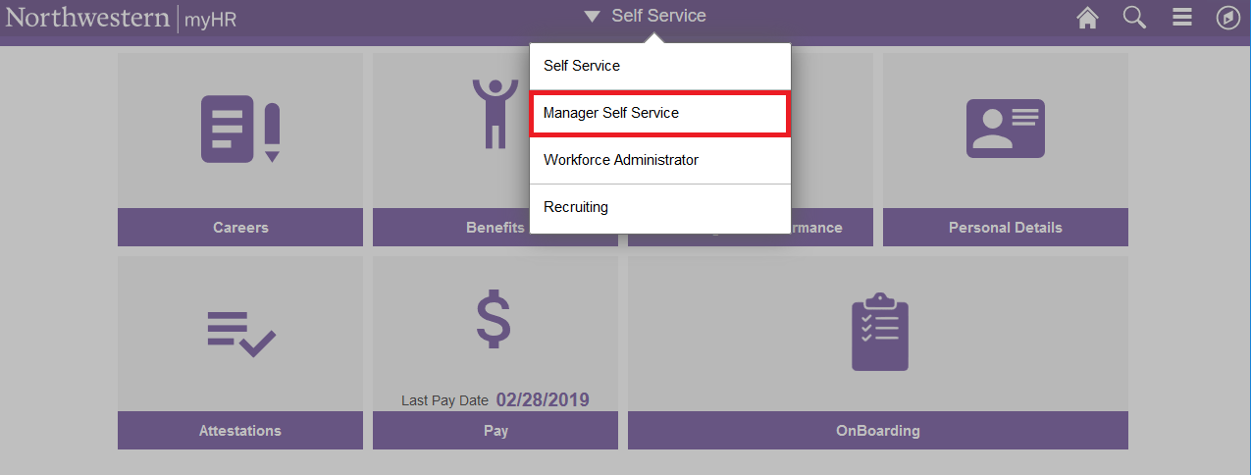

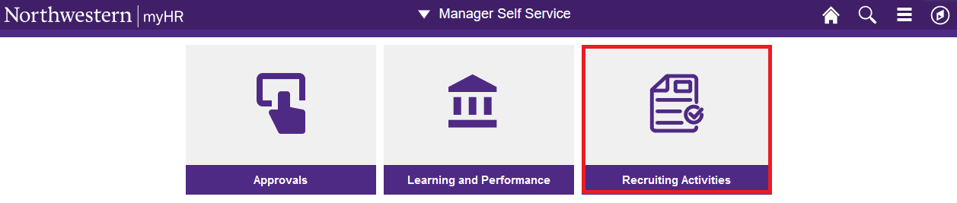

- Fluid Design for Additional Self Service Pages
The Direct Deposit page has been updated to reflect the look and feel of other Self Service pages.

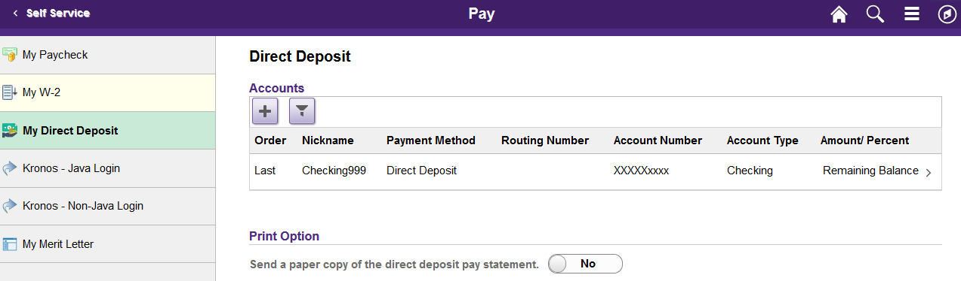

- Mobile-Friendly Experience for Job Seekers
The look and feel of the career site has been updated to a more modern and intuitive experience. Job Seekers can also now review job postings and submit their application more easily from any mobile device.

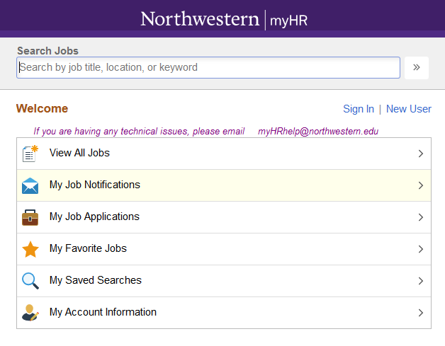

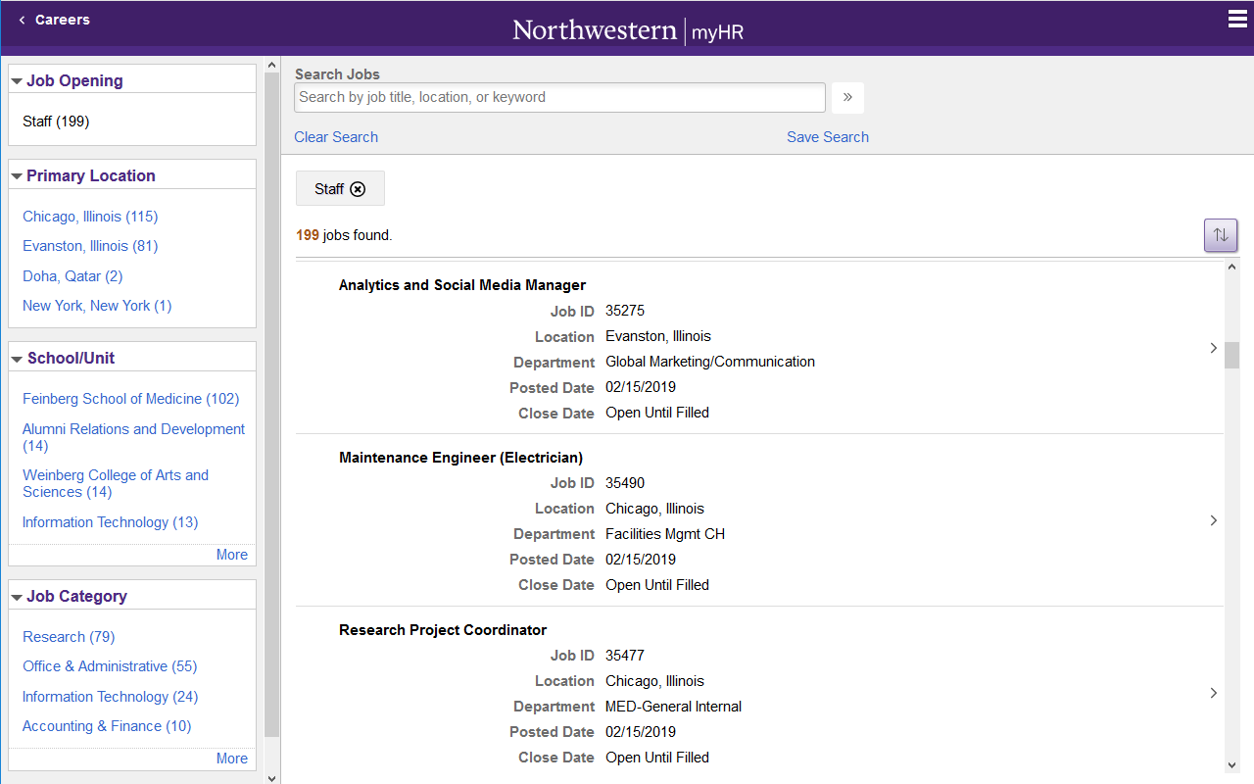

- Onboarding Portal for New Staff Hires
For new staff hires starting on, or after, May 1, 2019, an Onboarding portal will be available to guide them through their HR onboarding tasks. The new Onboarding tile will be available to new hires in Self Service for their first 31 days.
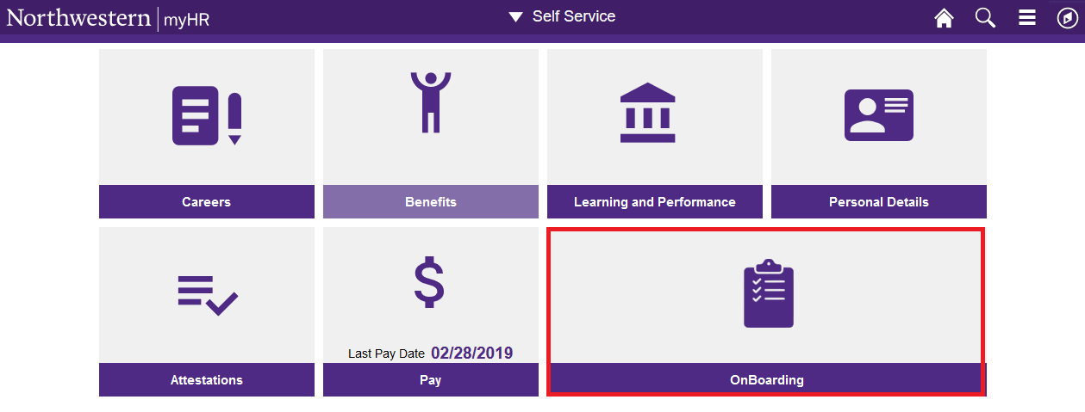

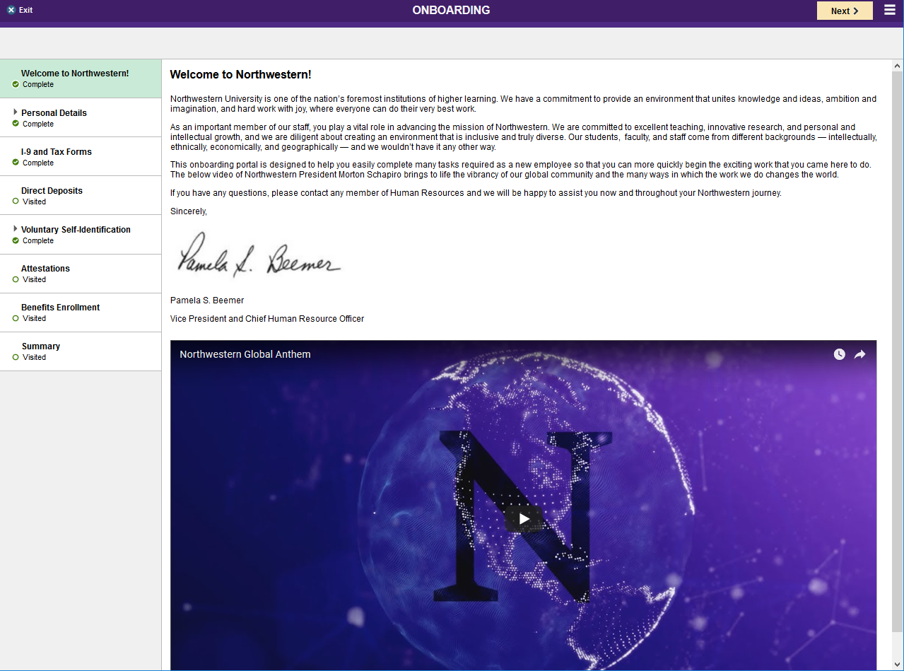

For questions regarding Recruiting, Careers and Onboarding, please contact HRTA@northwestern.edu

For questions regarding other myHR functionality, please contact myHRhelp@northwestern.edu

