Monitoring Group Trip Compliance as a Trip Organizer

This training guide is for Northwestern schools, units and departments where a Trip Organizer monitors students’ compliance with pre-departure trip requirements on behalf of a trip leader. It describes how to check progress and send reminder messages to students with outstanding trip requirements. A recent directive from the Office of the General Counsel is to “strive for 100% compliance,” regarding the completion of pre-departure trip requirements, focusing on the Signature Forms. OGSS’s experience is that students respond better to reminders from trip leaders, faculty supervisors, trip organizers or grant administrators than OGSS staff. However, in circumstances where these individuals have technical difficulties accessing the International Travel Registry (ITR), OGSS can assist with this process.

First, go to northwestern-travel.terradotta.com and log in with your Campus ID. Once logged in, click on the “Search” tab, and pick “Trip Search” from the drop-down menu.

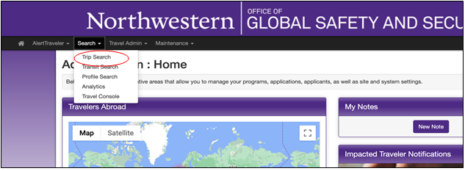
- To monitor compliance for a trip, search by the Trip Leader’s name and trip dates:
- Adjust the “Date Filter” to match the dates of the trip you are searching for
- Type the Trip Leader’s name in the “Traveler” section, wait for it to pop-up and select it
- Click the “search” button.
- Once you see the Trip Leader’s trip, click on the “Trip Name”.
The search button is the “apply filter” button next to the filter.

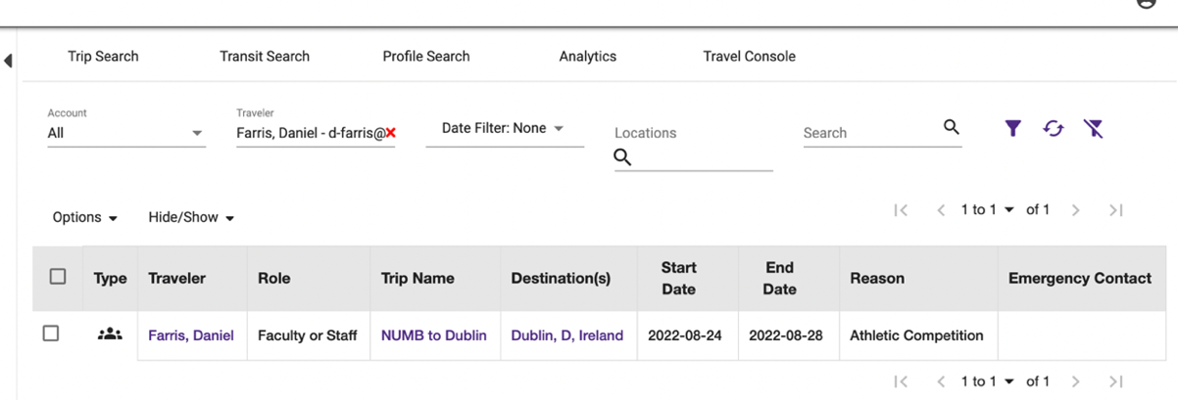
To Search
- When the trip opens you can click on the “Group Travelers” tab to review requirement completion. From the Group Traveler’s tab, you should see students’ requirement completion progress.
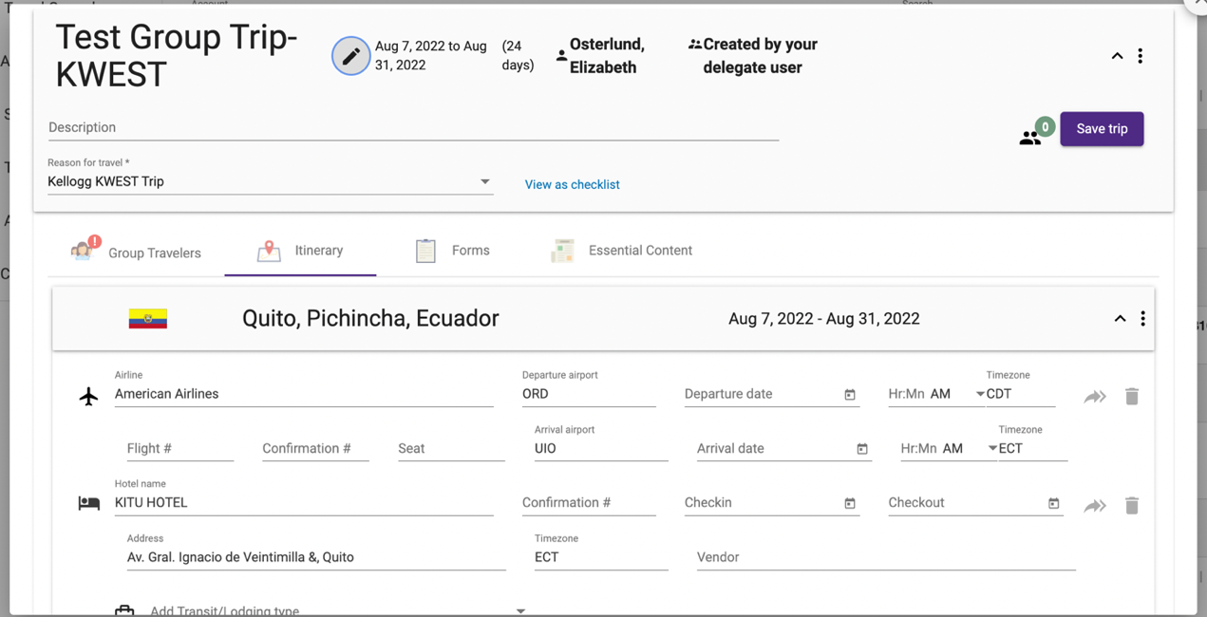

- A student with all dashes has completed all their pre-departure requirements and is ready to travel. The numbers show how many outstanding requirements a student has in each category.

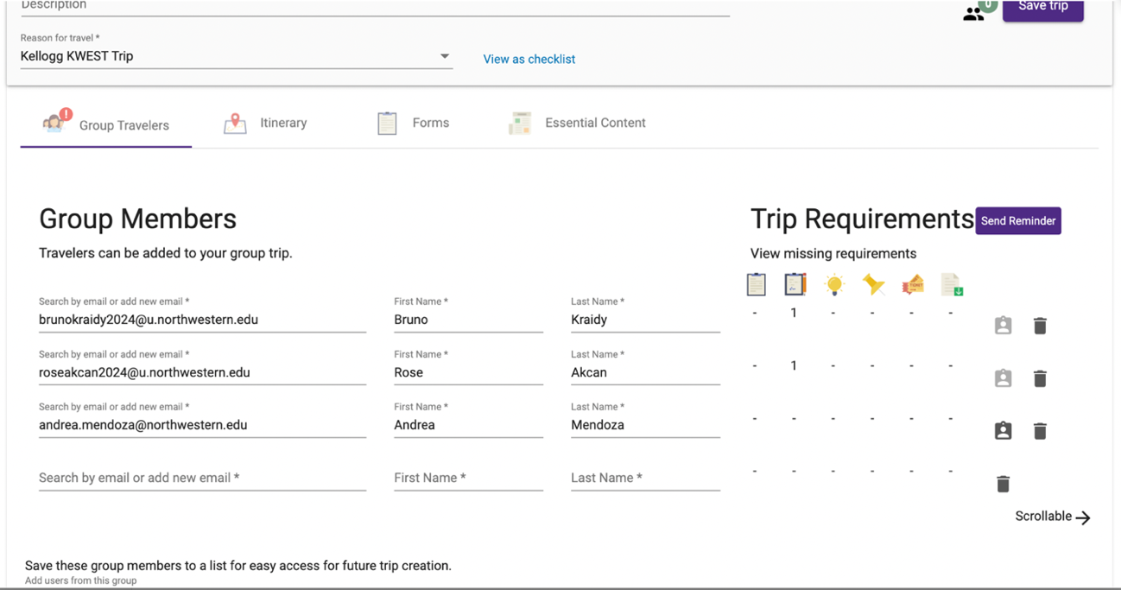
Hover over the requirement icons for a reminder of what they represent.

*To delete travelers who dropped out of the group trip, click on the little garbage can icon on the right.

- A trip organizer can use the “Send Reminder” button to send students an email to remind them that they are still missing the requirements. Note, an additional message must be included for the reminder email to send. Sample messaging is provided below.

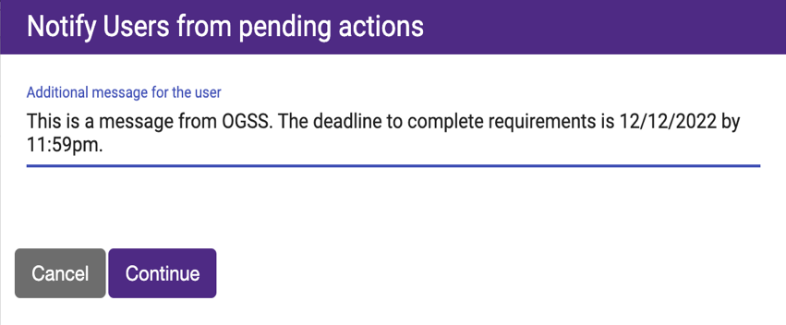

Sample Messages to Send through the ITR.
1st Message: Dear (School, Department or Unit) traveler: (School, Department or Unit) and the Office of Global Safety and Security remind you to use the weekend to complete your mandatory trip requirements due DATE HERE! The process is short and straight-forward.

2nd Message: This is your last chance to complete your pre-departure trip requirements before you fall out of compliance with university policy and jeopardize participation in future Northwestern travel. The deadline TIME AND DATE HERE.

1st Message: Dear (School, Department or Unit) COUNTRY + MONTH (example: Tel Aviv January) trip participant: You are one of NUMBER HERE students who hasn't completed their trip requirements in the International Travel Registry. Please do so by TIME AND DATE HERE. The process is short and straight-forward.

2nd Message: This is your last reminder to log into the Northwestern Travel Registry and complete your pre-departure trip requirements or you will be considered out-of-compliance, and your status will be reported to the Director of Academic Affairs OR OTHER TITLE OF AUTHORITY. The deadline is TIME AND DATE HERE.

Sample messages to send via email:

This process is recommended for students who’ve missed the trip requirement deadline. Unlike ITR messages, an email can be tailored to individual students. You may also consider other forms of communication with your students which have been reportedly more successful from past trip leaders include sending a text message or using WhatsApp. If the trip is associated with a class, try to reach them through Canvas or Slack, if applicable.

Dear (name of student),
(School, Department or Unit) and the Office of Global Safety and Security reminds you that all students are required to register their university-affiliated travel with Northwestern and complete all designated trip requirements. The process is short and straightforward. To begin, log into the International Travel Registry with your Northwestern credentials. If you’re having trouble accessing the site, please email globalsafety@northwestern.edu and the OGSS Data Analyst will assist you. Registration is due two weeks prior to departure for NAME OF DESTINATION.
--
Dear (name of student),
(School, Department or Unit) and the Office of Global Safety and Security reminds you that all (undergraduate or graduate and professional) students are required to register their university-affiliated travel with Northwestern and complete all designated trip requirements. The process is short and straightforward. Registering will allow the Office of Global Safety and Security to share health and safety resources, destination-specific intelligence and reach out in an emergency abroad.
To begin, log into the International Travel Registry with your Northwestern credentials. If you’re having trouble accessing the site, please email globalsafety@northwestern.edu and the OGSS Data Analyst will assist you. Registration is due two weeks prior to departure for NAME OF DESTINATION.

