GlobalProtect
To launch GlobalProtect, look for the globe icon in the lower right hand corner of your screen, near the clock. It might be hidden. You may have to click the up arrow.
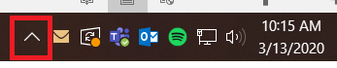
The GlobalProtect icon is a grey & white globe
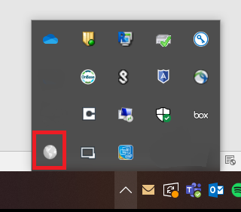

Right click on the globe and click on Connect
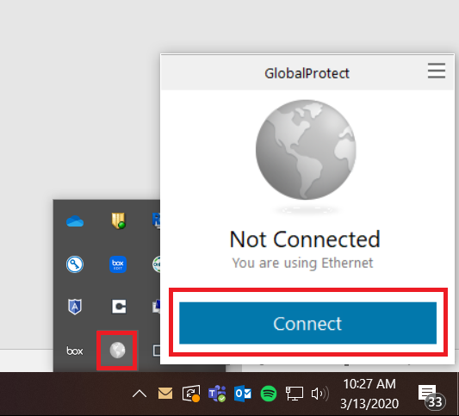

Sign in with NetID username and password
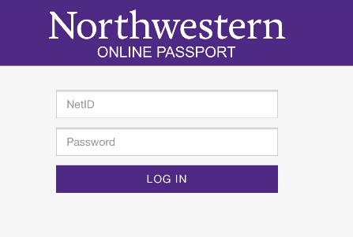
You will be prompted for DUO. Click on the “Remember me for 30 days” to avoid the DUO screen for 30 days. Make your selection.
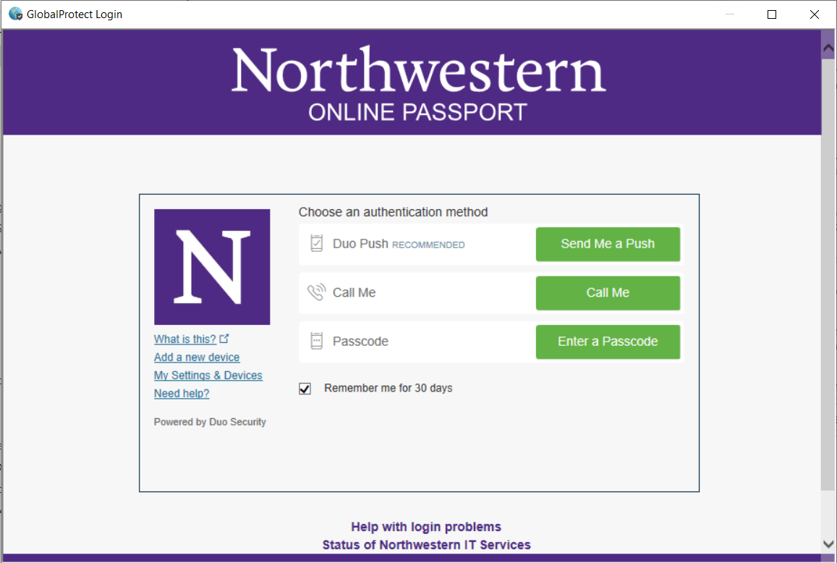
Once connected, the globe will change color
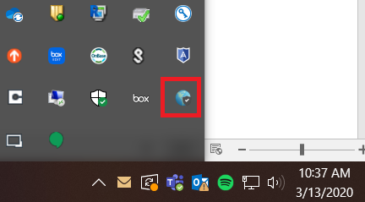
You have successfully connected to the VPN
If for some reason you need to reinstall GlobalProtect, please follow the instructions found here: https://kb.northwestern.edu/94726

