PETTY CASH FUNDS

Introduction

A petty cash fund is an amount of currency issued and held by a department to cover payments to research participants and all departments maintaining a petty cash fund should exercise controls over its use.

- No single expenditure of more than $100.00 may be paid through the petty cash fund. Amounts in excess of $100.00 must be paid using a Non-Travel Expense Report through and submitted to Accounts Payable. For additional information, please consult the Travel Expense Policy.
- A safer alternative for research participant payments is the PNC stored value card program. For more information on this program, please visit the Stored Value Card webpage.
- A petty cash fund should only be established for participant payments in research studies. For general departmental purchases a Corporate Card should be used. For more information on how to obtain a card, please contact the Corporate Card office.

For specific policy guidelines, please consult the Cash Management Policy.

Establishing or Increasing a Petty Cash Fund

- To open or increase a petty cash fund, a Direct Payment Request (DPR) form, approved by the department head or business manager, must be submitted for approval to the Accounting Services department on the Evanston campus. The DPR form should never be saved as a template. Please visit the following page to create a new DPR.
  - If using a grant account, an approval from ASRSP will also be needed.
  - A custodian for the fund must be appointed and is the party responsible for safekeeping, disbursing, and balancing the fund. The custodian must be named as the payee on the DPR.
  - The fund 110 and the account number 10266 must be entered on line1.
  - The chartstring that will be charged for replenishment of the fund should be listed in the description section of the DPR.
  - The limit for a standard amount for a petty cash fund is $300.00. Any amount in excess of $300.00 will need the approval of the Director of Accounting Services.
  - After completion of the necessary approvals by Accounting Services and ASRSP (if needed), funds will be disbursed at Depository Services.
- The payee must present their valid Wildcard, original DPR with wet signature and scanned copy of the DPR with the approvals from Accounting Services and ASRSP (if needed) to obtain the cash.
- The custodian and requestor cannot be an approver on the DPR for establishing, increasing or replenishing the petty cash.

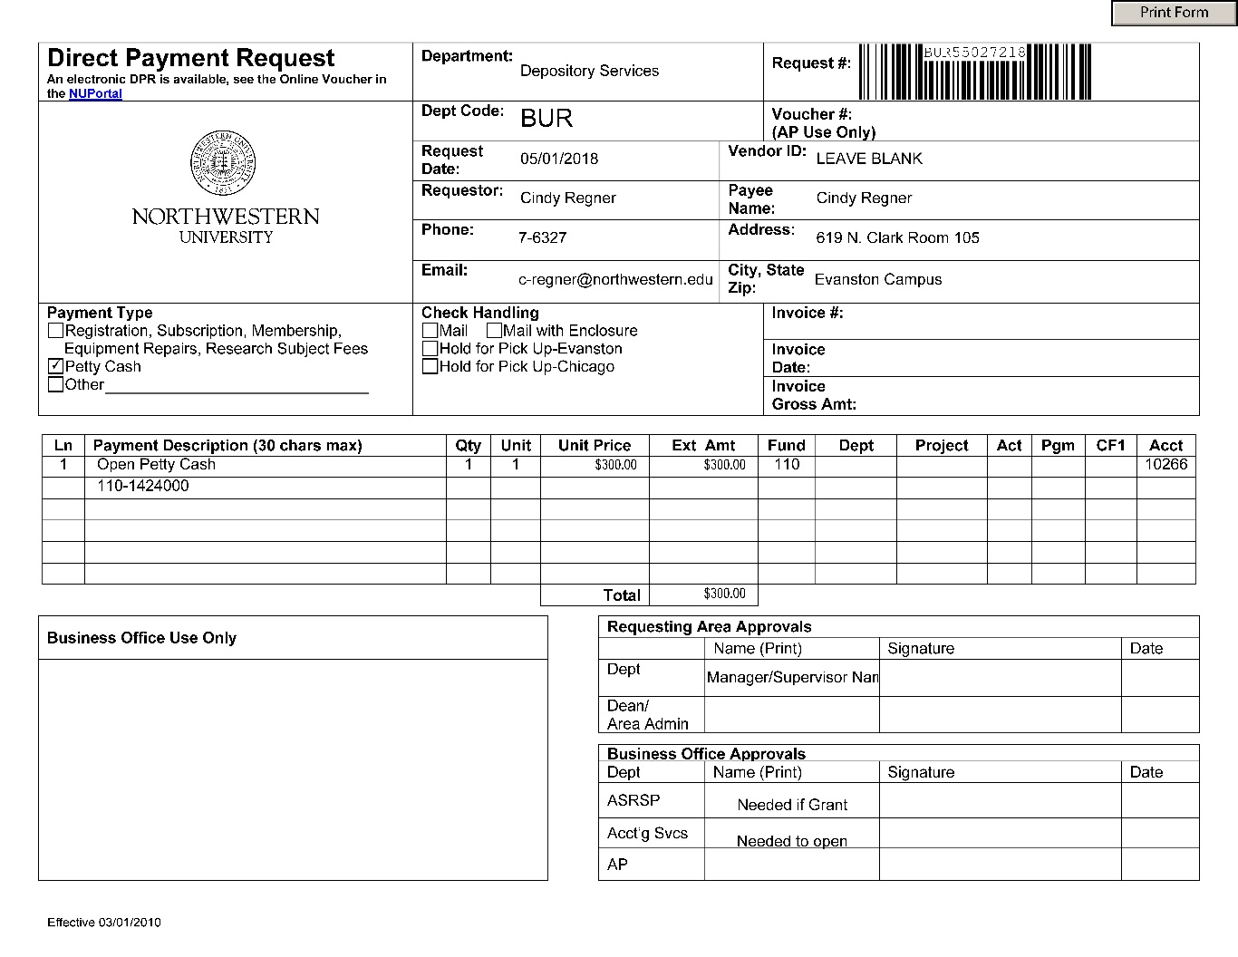

- Once accepted by Depository Service, the DPR is then forwarded to Accounts Payable. When received by Accounts Payable, the DPR is archived with back-up documentation and the chartstring listed on the DPR is then debited.

Custodian Responsibilities

- The custodian of the fund is fully responsible for the safekeeping of the fund and for its proper usage. The custodian must exercise caution in the administration and protection of the fund in his/her possession.
- Access to the fund should be limited to the custodian only.
- Petty cash funds must not be combined with any other funds or used for any purposes other than for research participant payments.
  - Petty cash cannot be loaned or borrowed for personal use.
  - The fund may not be used to cash personal checks.
  - Employee gifts should never be purchased with these funds.
- The custodian should make pay-outs directly to the individual requesting reimbursement. Pay-outs should not be made to departmental employees for delivery of currency to another party.

- The custodian cannot reassign the use of the petty cash fund if the original project number is closed and a new one issued. If for any reason the chartstring changes from the original request, the petty cash fund needs to be closed and reopened with the correct chartstring that will be used for replenishment.

- Any discrepancies in the fund are the responsibility of the custodian and the departmental administration.
  - It is the responsibility of the custodian to follow current University policies and procedures in maintaining the petty cash fund.
  - Mishandling or loss of funds may result in dismissal and/or prosecution of involved employees and/or relinquishment of the fund by the department.

- If any questions or issues, please contact Accounting Services or Depository Services.

Procedure to Change Custodian

If the custodian is leaving the department or terminating employment, transfer of the fund to a new custodian is required. The fund should be counted and reconciled by the current custodian and then turned over to the new custodian. The new custodian should then acknowledge receipt of the fund by signing the Petty Cash Fund Transfer Form documenting the transfer of funds and the accompanying responsibility. The form below may be printed from this document and used for this purpose; the completed form should be sent to Accounting Services.

Fund Safeguarding

- Petty cash funds are to be maintained on an imprest basis, which means the amount of the fund must remain constant.
  - The total value of currency, coin and petty cash receipts on hand should always equal the authorized amount of the fund.
- Each fund belongs to Northwestern University and must be kept on University property at all times.
- The fund can be subject to surprise count by Accounting Services, Depository Services, or the University’s external auditors during normal business hours.
- Department supervisors should perform surprise counts on a regular basis.

Petty Cash Fund Disbursements

- Research subjects:
  - Payment up to $100.00 cumulative for the calendar year is allowed. Prior grant authorization from ASRSP (Accounting Services for Research and Sponsored Programs) may be required. For more information, please consult the Human Subject Payments policy.
  - Food purchases made at restaurants under $65.00 are allowed with proper documentation (receipts).
  - A research participant can be reimbursed for mileage, public transportation, Uber and taxi up to $100.00. Travel reimbursements over $100.00 should be reimbursed by check. For more information on mileage reimbursement, please consult the travel webpage.
  - Research studies must provide a signature log which includes participants’ name, date of research, amount paid, and signature of participant. Departments should use the Research Participant Cash Payment form for receipt for replenishment of petty cash.
- Departmental research subject reimbursement:
  - A receipt or invoice should be obtained for each expenditure for research participation. Vendor receipts should show the date, amount, and reasons for expenditure. With this documentation, the custodian can approve the request and reimburse the purchaser.
  - Tax will not be reimbursed for purchases of food and incidentals from local vendors or grocers. The tax exempt form should be used for these purchases and can only be used by NU employees.
  - If the vendor does not normally furnish receipts of the expenditure (for example, bus or train fare), the purchaser must complete and sign a Petty Cash Pay-Out Form with the appropriate dates, amounts, and reasons for expenditure. The custodian can then approve the request and reimburse the purchaser.
  - No amount over $40.00 will be reimbursed without an original receipt.
  - Along with the DPR form, the employee seeking reimbursement should:
    - Fill out a Petty Cash Pay-out Form
    - Include the explanation of purchase
    - Sign and date
    - Attach the detailed receipt or invoice for the purchase with scotch tape on all four sides of the receipt.
    - The designated supervisor or dean must also sign/approve the reimbursement form; a proxy signature will not be accepted.
  - Multiple purchases or pay-outs may be listed on the same Pay-out form when the chartstring to be charged and the employee being reimbursed remain the same.

Petty Cash Fund Replenishments

- Petty cash funds should be reconciled and replenished on a biweekly basis at minimum
- Reimbursements should not be made for receipts presented that are older than 90 days. For more information, please consult the 90-day justification memo.
- Disbursements from your fund will be replenished by preparing a properly- approved DPR noting the chartstrings and amounts to be charged.
- To replenish a fund, currency reimbursements may be obtained from Depository Services. Back-up documents required:
    - Original DPR
    - Original receipts
    - Pay-out forms
    - All approvals should clearly indicate the amount requested. It is recommended that an adding machine tape documenting the total be included in the back-up.
    - A valid Wildcard is always needed when replenishing funds at Depository Services or US Bank.

Theft, Loss, Overage and Shortages

- If burglary or theft is suspected, the University Police should be notified immediately after the discovery. 847-491-3456.
- To reimburse a fund for stolen/lost currency, a confirmation should be requested from University Police acknowledging that the theft was reported and properly investigated. This confirmation must include the incident number and the exact dollar amount lost or stolen and then attached to the DPR as detail to support the request for reimbursement.
- Funds lost due to circumstances beyond the control of the custodian must be repaid from the unit’s departmental or operating funds.
- Overages in the fund must be deposited with Depository Services and a CRT must be created.
- Shortages are to be repaid from the unit’s departmental or operating funds and must be fully documented in writing. Shortages in the fund must be reimbursed and this reimbursement must bring the account back into balance.
- If any questions or issues, please contact Accounting Services or Depository Services.

Annual Verification of Fund

Accounting Services sends an annual verification form to the custodian. Petty cash funds will be verified by the department head or designee. Under no circumstances should the custodian verify the fund. Rather, the department head or designee should perform the verification. Once completed, the verification form should be returned to the Accounting Services department. Failure to verify funds and return the form may result in mandatory closure of the petty cash fund.

To Close or Decrease a Fund

If the petty cash fund is no longer needed for the purpose intended, or if the amount of funds on hand exceeds the departmental needs, it is the custodian’s responsibility to close or decrease the fund.

To Close a Fund

The custodian should first fully replenish the fund by preparing a DPR with the pay-out documentation attached. Currency must be used to close a petty cash fund.
- If receipts are presented, a DPR needs to be created and replenishment made at Depository Services or US Bank.
- The full fund total will then be deposited using a Cash Receipt Ticket (CRT).
- The chartstring used for the CRT to close the petty cash is the same as when the fund was originally opened: fund 110 and account 10266.
- The description on the CRT should state “close petty cash” along with the custodian’s first initial and last name.
- A copy of the CRT deposit receipt received from Depository Services or US Bank, and the chartstring that was used to replenish the petty cash, should be emailed to Accounting Services stating that the petty cash fund has been closed.

To Decrease a Fund

Use the same procedure detailed above.
- The Cash Receipt Ticket (CRT) form description should contain the fund total, the amount of reduction and the fund custodian’s first initial and last name.
- A copy of the committed CRT, deposit receipt received from Depository Service or US Bank, and the chartstring that was used to replenish the petty cash should be emailed to Accounting Services.

