Depositing Checks and Cash to the Bank

The University’s procedures with regard to the acceptance and handling of checks and cash are defined and outlined below.

For specific policy guidelines, please consult the Cash Management Policy.

For gift revenue, please contact GRS. For more information on gift depositing information, please consult the Gift Clearing Guidelines.

For grant revenue, please contact ASRSP with any questions.

Check Acceptance

- All checks must be drawn on a U.S. Bank in U.S. dollars. For foreign checks (drawn on a foreign bank or in a foreign currency), please see “Foreign Checks” section below.
- Look for any deposit limitation messages pre-printed on the check, “not valid after 90 days”, “not valid over $500.00”, “Final Payment”, etc. If the check violates any of this language, please ask the issuer of the check to reissue the check correcting the deposit limitation message.
- Verify that check is not stale-dated (older than 90 days) or post-dated (dated for a future date). If check is stale or post-dated, return the check to the issuer.
- The check should be made payable to “Northwestern University”. If the check is made out specifically to a department or an individual, it must be endorsed as such.
- Written and numerical amounts must be identical. If they do not match, return the check to the issuer.
- Check must be signed by payor. If check is not signed, please ask the payor to sign it.
- For tuition check payments, the customer/student information must be written on the front of the check.
- Starter/blank checks may not be accepted without the approval of an authorized departmental supervisor. Proper identification (valid Driver’s license, State ID, Wildcard or NU affiliated ID) must be presented before being approved by the supervisor.
- The check must be restrictively endorsed immediately with a departmental bank deposit stamp. Contact Depository Services at depository.services@northwestern.edu for information on ordering the correct endorsement stamp for your department.
- No third-party checks can be accepted. If a check is received drawn on a third-party, return the check to the issuer for reissuance.
- Departments are not authorized to return any excess to the payor in the event that the check exceeds the amount due to the University. In this situation, please ask the issuer of the check to re-issue for the correct amount.
- All checks received by a department must be deposited as outlined in Preparing Your Bank Deposit.
- Currency or checks, received as a refundable deposit on goods or services, may not be held in the department. Rather, this currency or checks must be deposited and later refunded through Accounts Payable.

Foreign Checks

Any check not drawn on a U.S. bank is considered a foreign check, even if the check is payable in U.S. dollars.

- Separate foreign checks from other deposits and deliver to Depository Services for transmittal to the bank. Chartstring information must be supplied in order to credit funds to the department.
- Depository Services will submit the check(s) to the bank for collection and will post the amount received to the department’s account when the equivalent proceeds (U.S. dollars) are remitted back to the University. The collection process for foreign checks may take several days to several weeks to complete depending on the foreign country currency.
- The U.S. dollar-equivalent proceeds will be based on any bank collection charge and the exchange rate at the time the check is presented for collection and any bank collection charges.

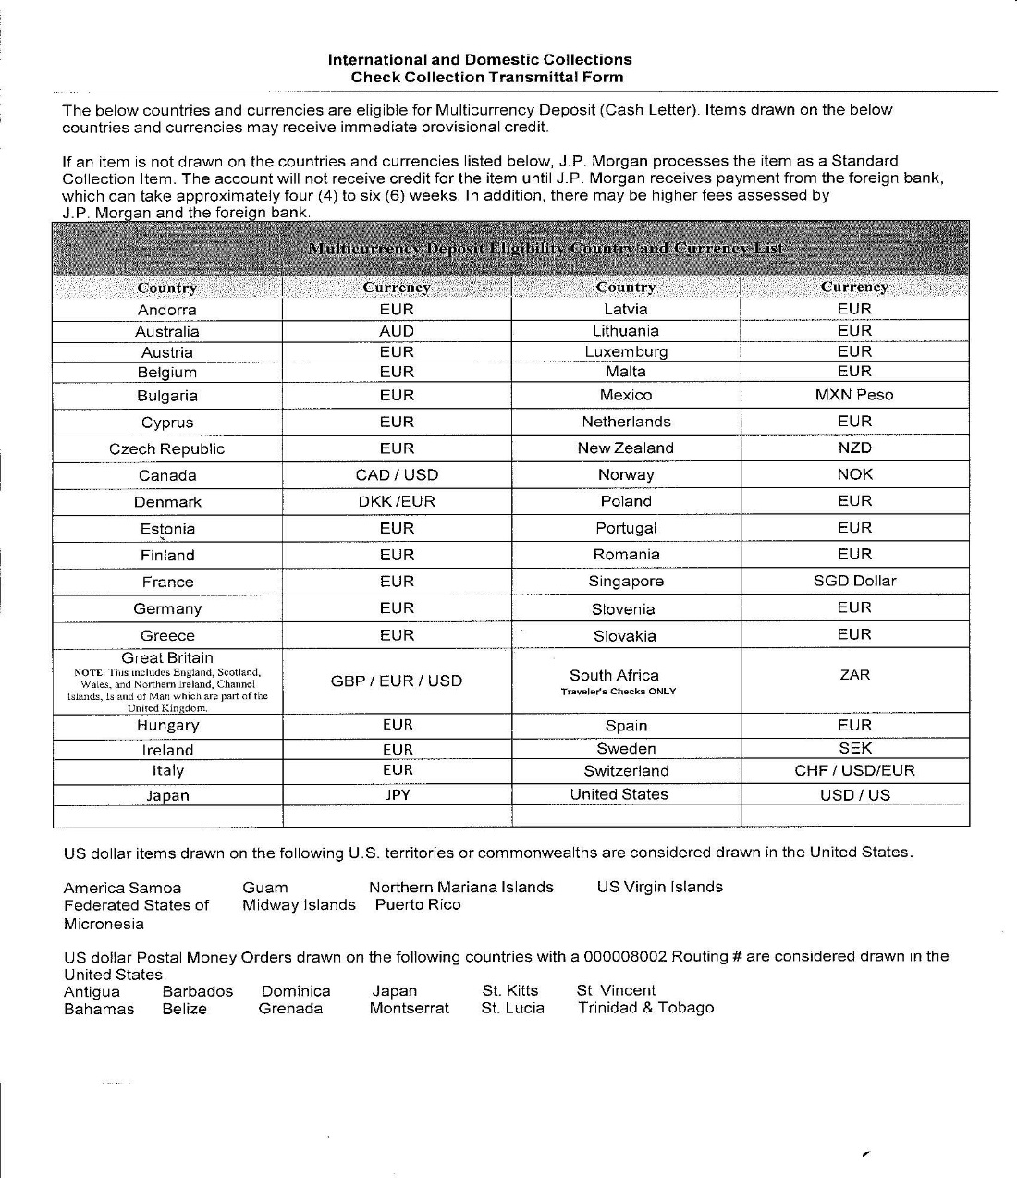

Endorsement of Checks

All checks must be restrictively endorsed to the University immediately upon receipt. This protects the check if lost or stolen.

For gift checks, please contact GRS. For more information on gift depositing information, please consult the Gift Clearing Guidelines.

The endorsement must include the following language:

For Deposit Only
Northwestern University
Department Deposit
XXXX7808
Location 10001*
Chartstring
_____________________

This is the *5 digit location number that is assigned to you by Depository Services and printed on your deposit slips and endorsement stamp.

The Federal Reserve has established a regulation to standardize check endorsements. All depositors’ endorsements are limited to the top 1.5 inches on the backside of the check, at the trailing edge of the check. This is where endorsements are normally placed. If you look at the face of the check, the endorsement area is directly behind where “Pay to the Order of” is printed.

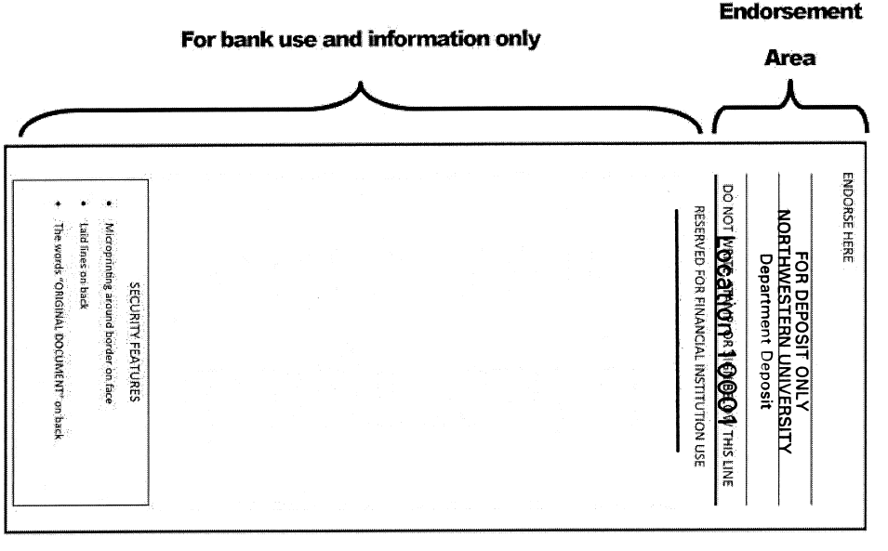

Any marks below the 1.5 inches on the check may obscure the bank routing number, which may cause delays in returning checks and forfeit the University’s right to recovery. The purpose of this regulation is to speed collection and returns. Failure to follow the above instructions may result in charges to your department.

Frequency of Deposits
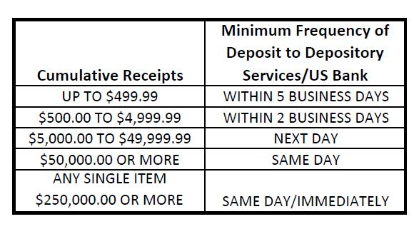

Forms and Procedures to be used

Cash Receipt Ticket (CRT)

The CRT is used by the department to record deposit information in NU Financials. After the prepared bank deposit is deposited at the bank, it will match electronically to the Committed CRT and post to the General Ledger in the financial system.

The entering of the CRT is located on the NU Portal.

Procedure to fill out Cash Receipt Ticket (CRT)

For detailed instructions on completing the CRT, please see training materials available on the FFRA website.

- Enter the revenue or balance sheet information on the account distribution lines of the CRT.
- Any backup information, for your internal use only, could be kept on a separate sheet of paper and retained in your office for attachment to your printed copy of the CRT, duplicate copy of bank deposit ticket and receipt from either Depository Services, US Bank or armored car carrier as well as any other pertinent balancing details, (including your merchant card reports).
- Specify the media/tender types in the Media lines on the CRT.
- Enter the deposit reference number for each cash, check, wire and ACH line item.
- Account Distribution lines (in total) must equal Media lines (in total)
- Deposit ticket number on CRT must be accurate. It must exactly match the number of the deposit ticket.
- Save or commit the CRT. Saved CRTs will not be reconciled with the deposit; reconciliation will only occur once the deposit is received by the bank and the CRT is committed.
- If you transport your bank deposit to Depository Services, you will receive a receipt for the deposit bag. If your deposit is picked up by an armored car, a manifest will be provided as a receipt from the armored carrier and the log book will be signed by the armored carrier. His or her signature will function as the deposit confirmation.

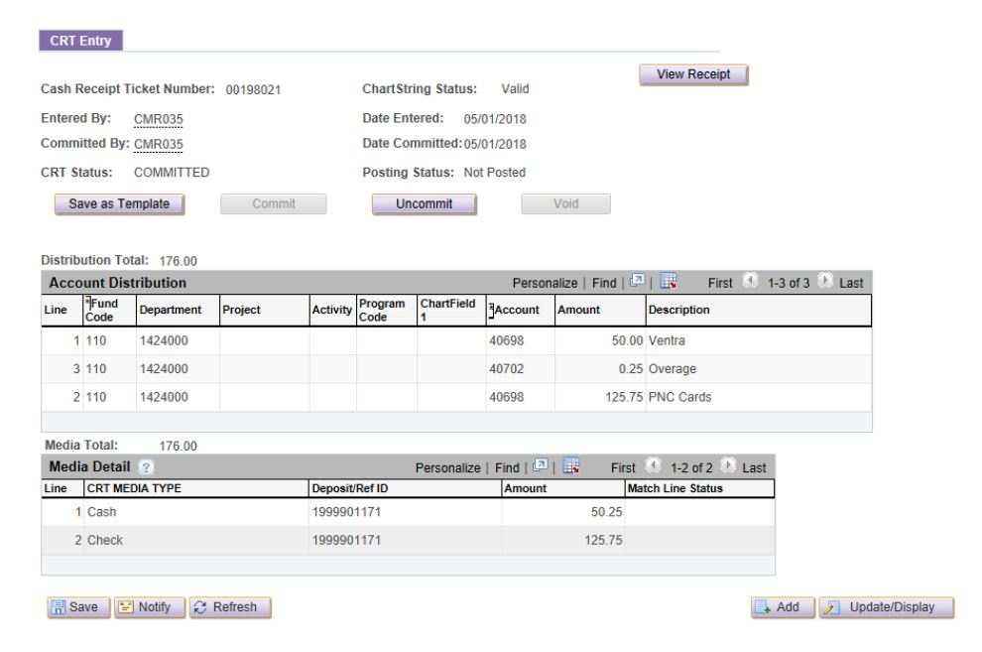

Any backup information (such as deposit receipt, copy of deposit slip and departmental logs) can be retained within the department.

Preparing a Bank Deposit

The person making the bank deposit should be someone other than the person balancing the day’s work.

- Enter date on the bank deposit slip.
- Count your currency, listing the totals by denomination on the calculator. Then, list the amount on the bank deposit slip.
- Run a calculator tape on all the checks and then place a paperclip around the checks. List the total on the first line for checks.
- Run a calculator tape of all totals and enter the total on the bottom line and again where it indicates “Please Enter Total”.
- Enter total number of checks, amount of cash (any amount is considered “1” item), and then enter complete number of items in the “total items” box.
- The bank deposit slip is a two-part form. The original will go in the bank deposit bag with the currency, coin and checks. The duplicate is retained by your department with the original balancing tapes run by the person balancing the day’s work.

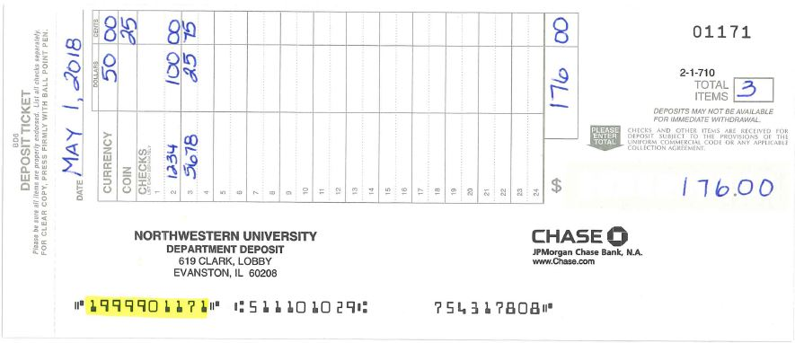

Preparing the Bank Deposit Bag

- Place all currency, coin, checks and original bank deposit slip in the deposit bag.
- All manufacturer’s bags are slightly different. You must fill out the “To”, “From”, “Amount” and “Date” spaces. (You might want to make labels for the “To” and “From” spaces.) On bags only containing checks, please write on the bag with a marker “CHECKS ONLY”. When depositing checks with cash or when depositing cash only, please write on the bag “MIXED”.
- The following address should be used on the bags

To: Chase Bank
30 S. Clark
Chicago, IL 60603

From: Your Department Name
NORTHWESTERN UNIVERSITY
Your department address
Evanston, IL 60208

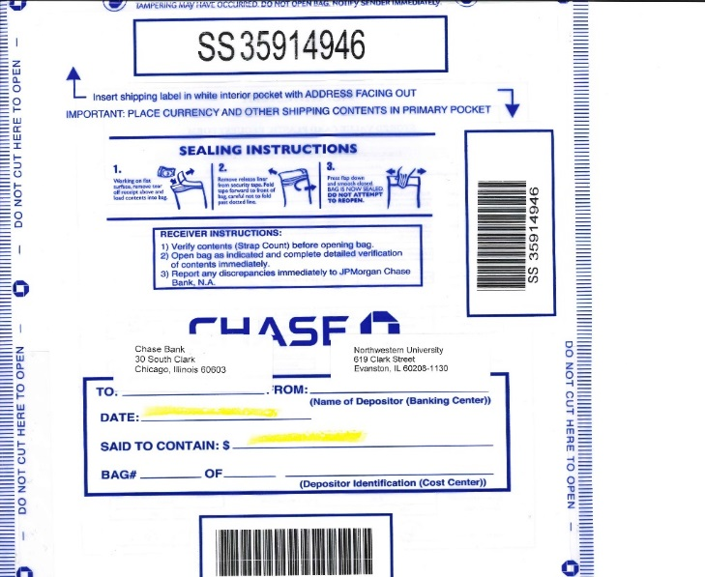

- If you have a check scanner, there is no need to create a bagged deposit for check-only deposits. However, a bagged deposit will be needed for cash.

Cash Receipt Reconciliation

Procedures to Reconcile Accounts

Verify “Match” and “Post” Status using CRT

Departments may retrieve committed CRTs online to verify matching and posting status of individual deposits and the overall CRT on your budget statement. Only CRTs with a posting status of “Posted” on the CRT will appear on the budget statements.

Using Committed Copies

Departments that have online access to NU Financials can look up their budgets in NU Financials using Cognos report GL008 2-3 days after the deposit is made, unless there is a problem with the CRT or the bank deposit. The amount posted in NUFinancials (from which your budget statements are produced) should be compared to the entry committed in the CASH RECEIPT TICKET (CRT) system. Changes made by correction journals or bank adjustments will not be reflected on the original CRT. Rather, they will be shown as separate line items on the budget statements.

Using Budget Statements

Total deposits and account balances should be verified against totals in the departmental budget records. An analysis of outstanding deposits should be made and any corrections needed should be made as soon as possible. It is important to establish revenue budgets to provide a basis for variance analysis on a monthly basis. An important management tool is the reconciliation of budget to actual activity.

How and Where to Report Discrepancies

If a deposit line is not found or a discrepancy is found on the budget statement or in NU Financials, contact Accounting Services for clarification.

If any error is found after a CRT has been committed, but not posted, the creator can “uncommit” the CRT. When uncommitting, the CRT is returned to “saved” mode and any changes can be made. When completed, the creator can then re-commit the CRT.

If the CRT has been committed and posted, the department must complete a correction journal in NUFinancials.

Any amount that is over or short is to be reported and reflected on the CRT using the appropriate chartstring with the account number 40702.

Where to Make Deposits

For those departments not receiving a direct armored car pickup on the Evanston campus, a department is to transfer deposits to:
Depository Services
619 Clark St.

Hours of operation: Monday, Tuesday, Wednesday and Friday 10:00-2:00.
Window closed on Thursday

depository.services@northwestern,edu

For those departments not receiving a direct armored car pickup on the Chicago campus, a department is to transport deposits to:
Depository Services
345 E. Superior St.
Mezzanine Level
Hours of operation: Monday - Friday, 9:00am-4:00pm (closed 1:00pm-2:00pm)
312-503-8525 k-west@northwestern.edu

How to Transport Deposits

- Transporting funds to Depository Services must always be a high priority and vigilance is recommended.
- Deposits containing currency may never be sent via campus mail.

For deposits with perceived additional risk (large deposit amount, late hour, etc.)
- A department may contact the Depository Service Office to arrange a special pick-up by the designated armored car courier at the depositing department’s expense.
- Currency deposits may be hand-carried by a departmental representative, or in special circumstances, University Police may be scheduled to assist. The transport schedule must be coordinated between the department and Depository Services hours.

Returned Check Procedures

Any checks returned by Northwestern University’s banks as uncollected are sent to Depository Services. Reasons for a returned check may include; non-sufficient funds (NSF), account closed, payor’s signature missing, refer to maker, and post-dated or stale-dated checks.

Depository Services prepares a deposit adjustment, debiting the originating department’s account for the amount of the check. A service fee (currently $30.00 per check) is also assessed.

The adjusting entry and copy of the returned check is emailed to the originating department for collection; physical copies of the check are not available. It is the originating department’s responsibility to notify the check writer and use due diligence to collect the amount of the check and the service charge from the payor. Generally, restitution should be in the form of currency, money order, cashier’s check, or certified check. All chargebacks are made to the chartstring where the check was originally deposited and account code 40704.

When restitution is obtained, the department should prepare a Cash Receipt Ticket (CRT) crediting the same account that was debited by Depository Services.

Check Scanning

For departments with frequent check-only deposits, a check scanner is a convenient method of depositing funds to the bank. Please visit the following link for more information: https://www.northwestern.edu/controller/treasury-operations/depository-services/remote-deposit.pdf

For more information on the check scanner or to request one, please contact Depository Services at treasury_operations@northwestern.edu

